Big Give Gage
Social Media Timeline
#BIGGIVEGAGE
Step 1: Like the Gage County Foundation on Facebook
Step 2: Like and share Big Give posts on Gage Co. Foundation page. Approximate timeline below.
June 1 – Save the Date
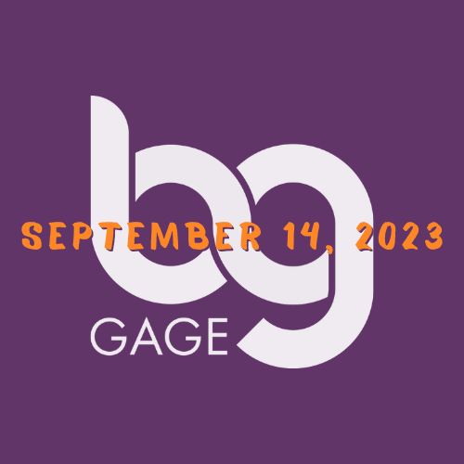

August 1 – Update Cover Photo
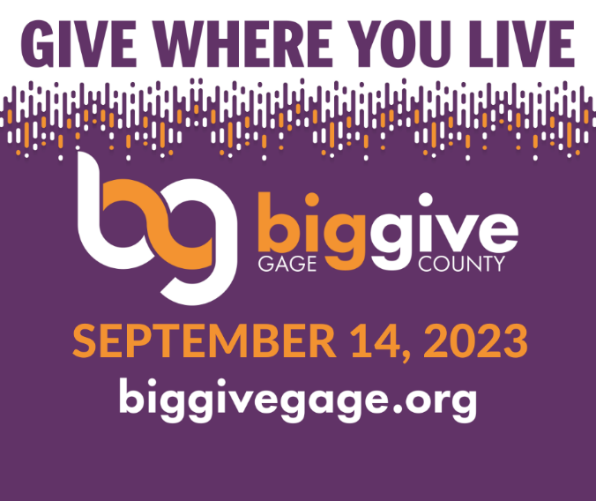

August 10 – One Month to Go
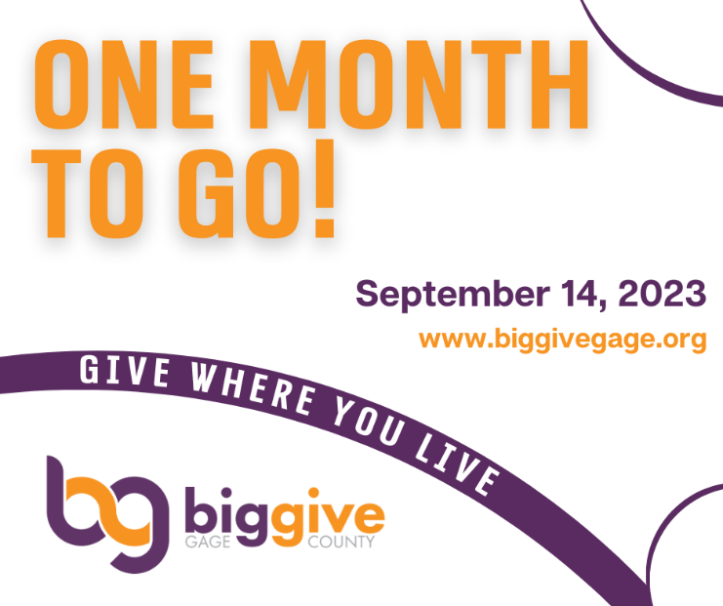

August 11 – Don’t Wait! Non-Profit Sign Up Deadline
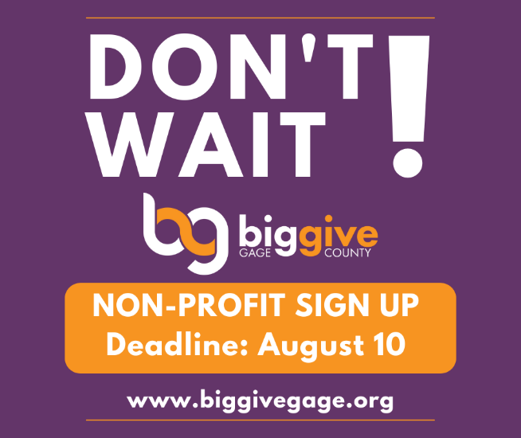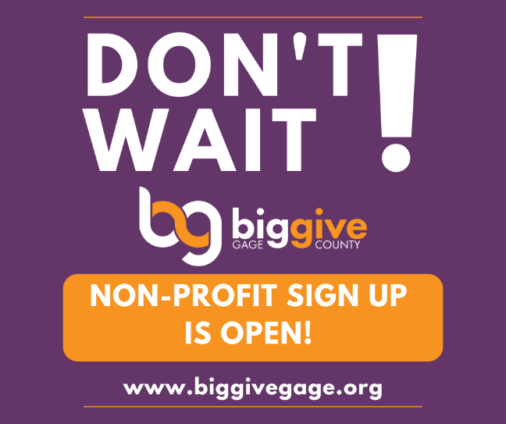

August 18-26 – Drum Roll…Participating Non-Profit Announcements
August 27 – Ways to Give
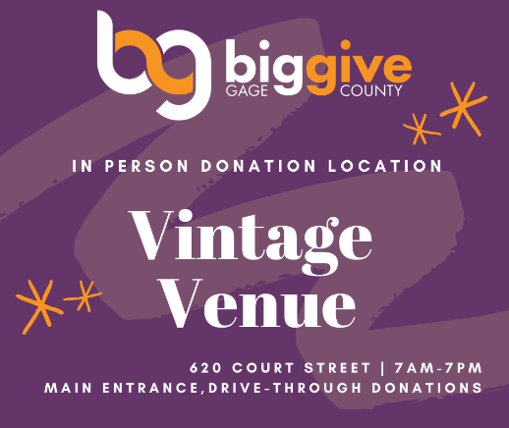

August 30 – Did You Know?
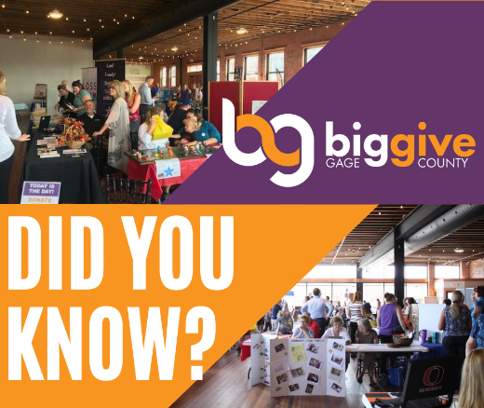

September 1 – Donate, Donate, Donate! Online Giving
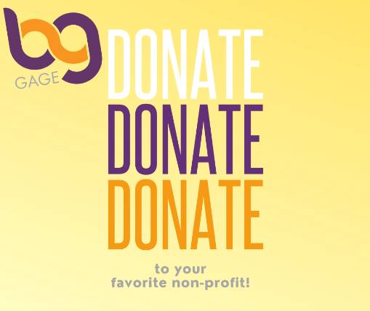
September 2 – 2023 Organizations Post
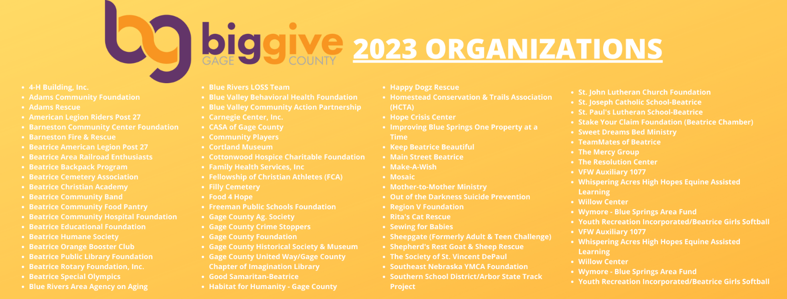

September 7 – Countdown Begins! 7 Days to Go!
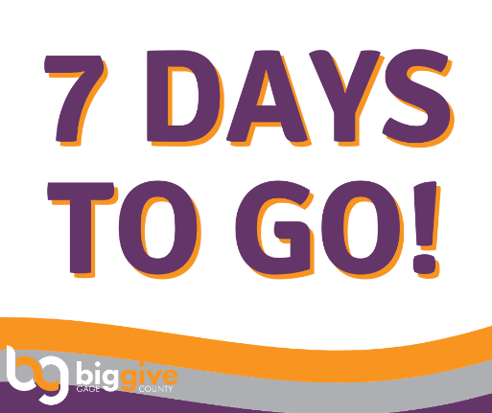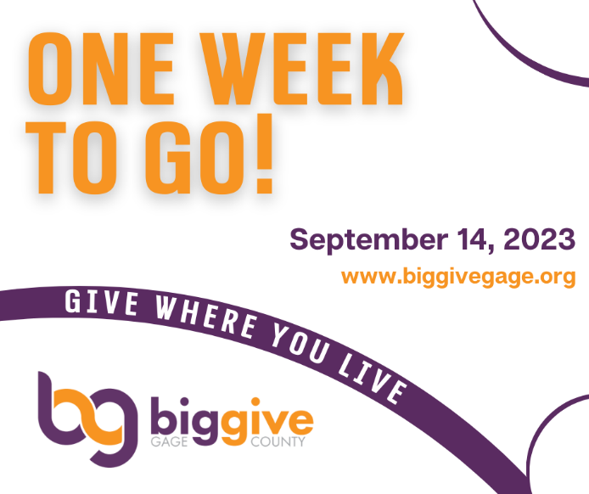

September 11 – Change Profile Pic to Big Give Gage Logo
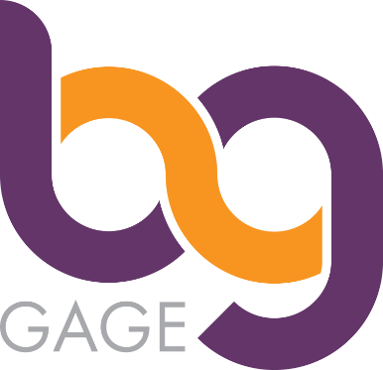

September 13 – Historic Day!
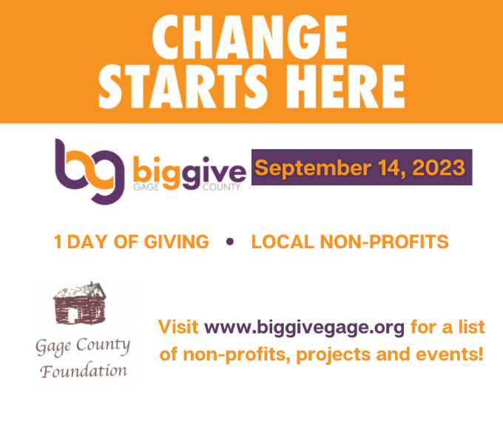
September 13 – Tomorrow is the Big Day!
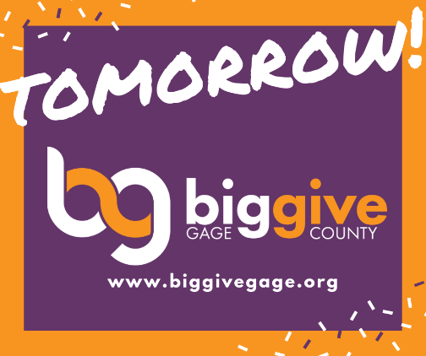

September 14 – Today is the day to GIVE BIG!
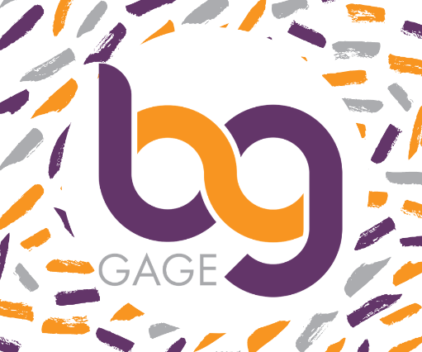

Step 3: Look out for these other posts to share throughout August & September:
- Join Us! - Radio Shows
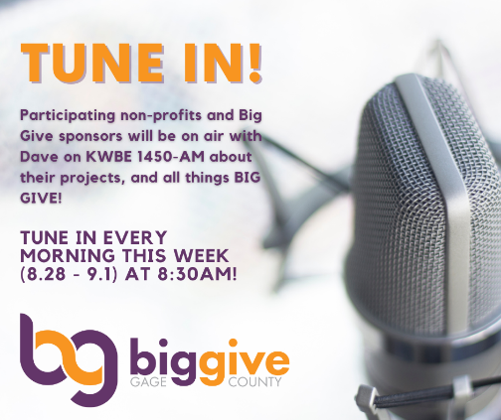
- Support in Style! – Big Give Tee-Community
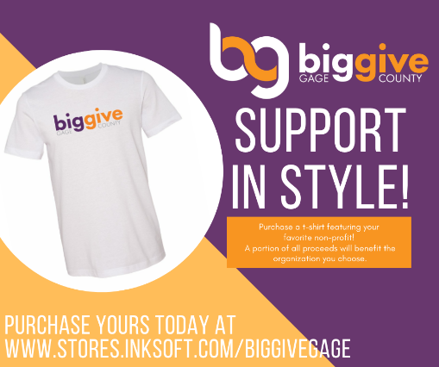
- Sponsor Recognition
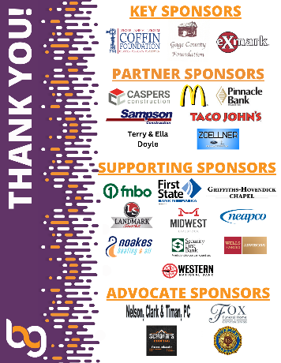
- Non-Profit Announcement
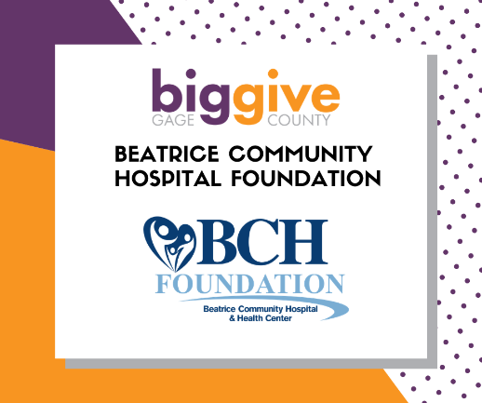

Tips & Tricks
for a successful Social Media Campaign
#BIGGIVEGAGE
- Like & SHARE original posts from Gage Co. Foundation page to your organization AND personal Facebook pages.
- Use hashtag #biggivegage when creating or sharing posts!
- Include link to www.biggivegage.org or to your specific non-profit site in post descriptions.
- Create your own posts! Use Canva or other FREE social media content sites that have ready to use templates & designs. (Hint: it’s where nearly all of the Big Give posts were created!)
- Schedule or share posts during high-traffic times. I time our posts for 12:00 pm and 4:30 pm. (Use the scheduling tool on Facebook to create posts ahead of time.)
- Be consistent! If you post 2-3 times a week, keep up that pace. Posting every day can be hard, and results in fatigue for both your org and your followers. Do what’s achievable in your time frame!

